JOB DESCRIPTION – Schedule B

Position: Activities Cashier

Location: Skyline Rotorua

Department: Activities

Responsible To: Activities Manager / Assistant Activities Manager / Cashier Supervisors

Key Tasks:

To provide excellent customer service to all customer, visitors and guests to the Skyline Rotorua complex.

To process all ticket sales, eftpos and credit card transactions, financial / administration reporting.

Provide information and advice to all customers, visitors and guests.

To maintain all standards of safety, hygiene, administration and security to the required legislative and procedural levels.

Main Duties & Responsibilities:

1. To be fully responsible for undertaking the duties of cashier.

Expected Results

(a) To maintain a high degree of accuracy, security and tidiness in all areas involving the handling of cash and associated records.

(b) To input daily revenue figures for the production of reports – Daily sheet.

(c) To process all ticket sales as per company policies and procedures.

(d) To ensure that all transactions are processed in a professional manner.

2. Responsible for undertaking general administrative tasks within the Activities Cashier position to ensure the efficient operation of the department.

Expected Results

(a) To ensure that all incoming calls and counter enquiries are responded to efficiently, providing the highest standard of customer service.

- To calculate foreign currency and process ticket sales as per daily schedule provided by the Administration department.
- To record all lost property and ensure that it is registered with Administration as soon as practicable.

- To comply with all established workplace Health and Safety policies.

- To be responsible for meeting and promoting established Health and Safety policies and practices.

- To be responsible for the completion of approved workplace Health and Safety documentation.

- Ensuring delivery of service that support Skyline’s sustainability goals by:

- Ensuring recycling and waste management practices are carried out where possible.

- Maintaining your work area to an environmentally acceptable standard.

- Making suggestions for environmental sustainability improvements.

LIVING OUR VALUES

Skyline Rotorua is a leader in the New Zealand travel and tourism sector. We are successful because of the commitment of our staff towards our company’s purpose; to share real fun with the world. We have three values that sum up how we communicate, behave, and work together to achieve our goals.

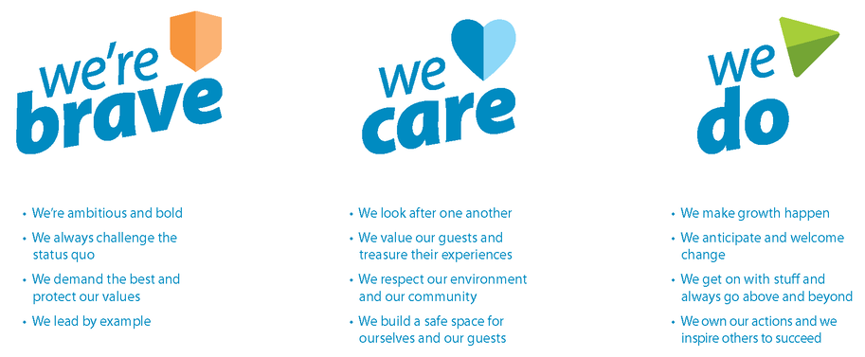
We’re Skyliners. We’re brave, we care, and we do everything we can to deliver real fun and make people smile.

Key Competencies:

- Customer Service Skills
- Ability to cope well under pressure
- Reliable and able to work unsupervised
- Able to follow procedures
- Able to work as part of a team
- Attention to detail
- Numerical ability
- Computer literacy

GENERAL

Any other duties that are related to and consistent with the above Job Description as directed by the Activities Manager or Senior Activities Supervisors.

Ensure full confidentiality is maintained at all times.

Attend staff training, induction and other professional development as directed.

Ensure all aspects of the Skyline Mission statement are upheld

Maintain a public image that is compatible with the highest possible standards whilst on the premises.

I accept the job description for the position of Activities Cashier.

Name: _____________________________________________ Date: ____________________

