JOB DESCRIPTION – Schedule B

Position: Activities, Track & Luge Cart Maintainer

Location: Skyline Rotorua

Department: Activities

Responsible to: Activities Manager

Functional Relationships: Gondola, Luge, Maintenance, Administration and HOD’s

Key Tasks:

- To assist the Activities Manager in operational improvement project tasks
- To assist the Maintenance Chief Engineer and Engineering & Development Manager with ad hoc tasks
- To assist the wider Activities team in day-to-day tasks.

Main Duties & Responsibilities:

- Your role will have a primary focus of assisting the site Activities Manager and Supervisors with implementing luge audit improvement projects tasks.
- To assist the Activities Manager and Supervisors with Activities operations when requested.
- To assist the Maintenance Chief Engineer & Engineering & Development Manager with activities and luge related tasks when requested.
- To assist with Luge cart maintenance, both preventative and repair when required.

- To operate all activities within guidelines, at a highly professional and motivated level.

- To maintain, promote and assist with ensuring the standards of acceptable behaviour at all Activities Department outlets are always met.

- To ensure adequate safety and security awareness at all Activities Department outlets is maintained to the highest level.
- To maintain effective communication with staff and management.

To comply with all established workplace Health and Safety policies.
- To be responsible for meeting and promoting established Health and Safety policies and practices.

- To be responsible for the completion of approved workplace Health and Safety documentation.

Ensuring delivery of service that support Skyline’s sustainability goals by:

- Ensuring recycling and waste management practices are carried out where possible.

- Maintaining your work area to an environmentally acceptable standard.

- Making suggestions for environmental sustainability improvements.

Living Our Values

Skyline Rotorua is a leader in the New Zealand travel and tourism sector. We are successful because of the commitment of our staff towards our company’s purpose; to share real fun with the world. We have three values that sum up how we communicate, behave, and work together to achieve our goals.
We’re Skyliners. We’re brave, we care, and we do everything we can to deliver real fun and make people smile.

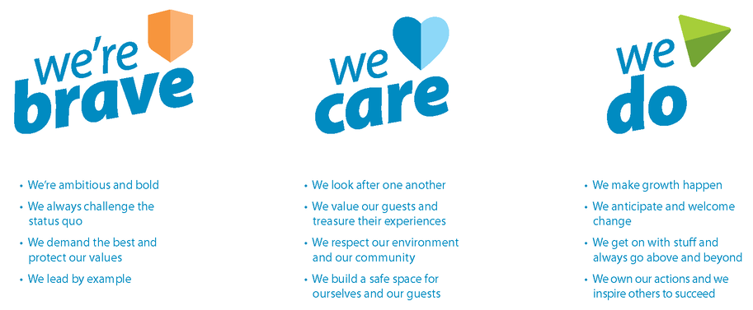

General

Any other duties that are related to and consistent with the above Job Description as directed by the Activities Manager or General Manager.

Ensure full confidentiality is always maintained.

Attend staff training, induction and other professional development as directed.

Ensure all aspects of the Skyline Mission statement are upheld.

Maintain a public image that is compatible with the highest possible standards whilst on the premises.

I accept the job description for the position of Activities & Track Maintenance Operator.

Name: _____________________________________________ Date: ________

