JOB DESCRIPTION

Job Title: | Food and Beverage Attendant
 | Food & Beverage
Group / Team: | Food & Beverage
Responsible To: | Operations Manager – Hospitality & Development  Food & Beverage Manager  Outlet Managers
Responsible For:  (Total number of staff) | 0
Job Purpose: | Food and Beverage Attendants are responsible for ensuring customer service and guest satisfaction across all Food & Beverage Outlets, which includes Stratosfare Bar & Restaurant, Café and Conference & Events.
Date last reviewed: | April 2022

SKYLINE VALUES

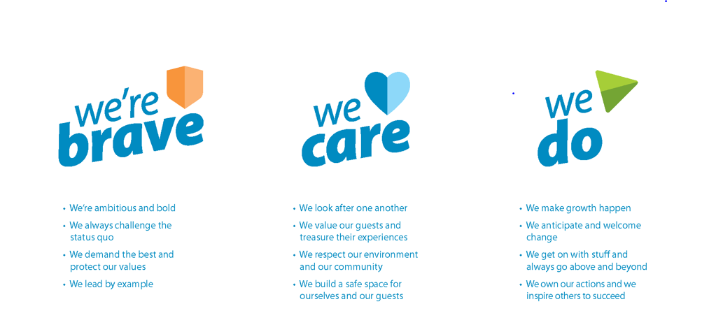

Organisation Context

Key Relationships

External:

- Guests
Internal:

- All F&B department
- Accounts/Reservations

Key Result Area
Main responsibilities

- To assist Skyline Queenstown in achieving budgeted profitability in all areas of the Food & Beverage operation.
- To be responsible for the hygiene and cleanliness of designated food and beverage service and subsidiary areas throughout all outlets.
- To ensure adequate security awareness of all food and beverage service outlets is maintained.
- To ensure competent cash, cheque and credit card handling procedures are strictly adhered to.
- To ensure quality wine/food service is maintained to a high professional standard at all times.
- To maintain all standards of Safety, Security, Hygiene, Sale of Liquor act 1989 and administration to all applicable legislative levels.
- To promote a personal image of professional grooming and product knowledge.
- To assist in any other area as and where directed to by the Duty Manager or Supervisor.
- Maintain quality dining experience throughout all Food & Beverage outlets.
- Perform basic cleaning tasks on a daily basis as directed.
- Maintain the cleanliness and sanitation of overall Food & Beverage department.
- Adhere to grooming and appearance standards consistently.
- Attend staff training, induction and other professional development as directed.
Guest Service

- To greet all customers with a smile & welcome.
- To be responsible for the quality guest service within the Food & Beverage operation.
- To deal quickly and correctly with any guest complaints within the established guidelines.
- To deal with enquiries and questions about Skyline and Queenstown.
- To ensure that the needs of all our guests are given priority over all other activities providing the highest level of quality guest service at all times.
- To operate the Food & Beverage Outlets within the guidelines relative to the sequence of service at a highly motivated and professional level.
- Promptly respond to guest requests and queries by resolving issues in a timely and efficient manner.
- Observe guests and ensure satisfaction with food and beverages throughout all outlets.

Health & Safety

- To observe and practise safe work methods
- To encourage other workers to work in a healthy and safe manner
- To discourage other workers from working in an unsafe manner
- To report or rectify any unsafe conditions or equipment
- To comply with the Health & Safety policy statement and H&S policies and procedures
- To work in a healthy and safe manner, providing a safe workplace to all employees.
- To use protective/safety equipment wherever provided and required.
- To report all incidents, work related injuries and near misses accurately and timely.
- To participate in any rehabilitation programmes as required.
- To be aware of procedures in the event of emergencies such as fire, bomb, in line with Company policy and legislation

Knowledge / Experience

Essential  (indicate years of experience required as appropriate) | Desirable
 | Food service experience – Experience working in a café or restaurant

Change to job description

From time to time it may be necessary to consider changes in the job description in response to the changing nature of our work environment– including technological requirements or statutory changes. This Job Description may be reviewed as part of the preparation for performance planning for the annual performance cycle or as required.

Employee Name Date
Employee Job Title

Approved: Manager Name Date
Manager Job Title

