

JOB DESCRIPTION

Job Title: | Line Cook
Department: | Kitchen
Group / Team: | Food & Beverage
Responsible To: | Executive Chef  Chefs
Responsible For:  (Total number of staff) | 0
Job Purpose: | The Line Cook will assist in maintaining the smooth and efficient day to day running of the kitchen so as to ensure maximum guest satisfaction. They will ensure that the Chef’s directions and task allocation are consistently followed through to the highest professional standard. The Line Cook shall maintain all legislative standards of safety, security, hygiene, and administration.
Date last reviewed: | November 2023

SKYLINE VALUES
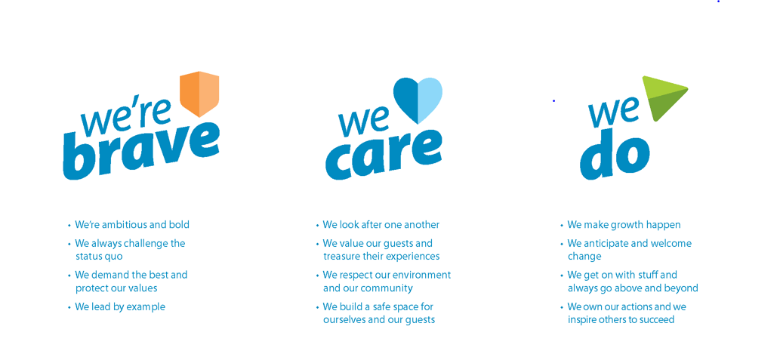
Organisation Context

Financial Responsibilities
- Controls a budget Y/N NO
- Maximum that may be spent without reference to manager $0
- Can spend unbudgeted capital Y/N. NO
- Is responsible for committing the organisation to long-term contracts NO
- Signs correspondence for Company NO

Person Specification

Knowledge / Experience

Essential  (indicate years of experience required as appropriate) | Desirable
 | Kitchen experience

General
- Assist in the maintaining the smooth and efficient day to day running of the Kitchen so as to ensure maximum guest satisfaction.
- To ensure that the senior chefs direction and task allocation are consistently followed through to the highest professional standard.
- To maintain all legislative standards of safety, hygiene and security to the applicable legislative levels.
- Any other duties, which are related to and consistent with the above Job Description as directed by the Executive Chef, or in their absence the Executive Sous Chef or Senior Chef.
- Maintain a public image which is compatible with the highest possible standards whilst on the premises.
- Ensure full confidentially is maintained at all times.
- Ensure all aspects of Skyline’s purpose and core values.

Kitchen
- Ensure an effective communication within the team members in your department and all other departments.
- Follow instructions/direction given by member of the kitchen brigade.
- Taking and serving food orders.
- Preparing food such as hamburgers, pizzas, fish and chips, chicken nuggets, and other items directed by the Executive Chef or Chefs.
- Washing, cutting, measuring and mixing foods for cooking.
- Operating cooking equipment such as grills, microwaves and deep-fat fryers.
- Cleaning food preparation areas, cooking surfaces, and utensils.
- May arrange delivery of prepared food.
- Be aware of guest feedback through guest comment cards and surveys.
- Minimise wastage and spoilage by correct utilisation of products.
- To ensure that the portion, product qualities, presentation and service of product is in accordance with the highest standards.
- To report any product or equipment defects to the Executive Chef, Executive Sous Chef or Senior Chef on duty.
- Assist with the maximisation of revenue through effective food cost control.
- Maintain productivity at all times.
- Ensure economical use of all resources.
- Assist with stock takes and ensure any discrepancies are investigated.

Guest Service
- To greet all customers with a smile & welcome.
- To assist with guest enquiries and comments, and actively promote Skyline Queenstown activities.
- To deal quickly and correctly with any guest complaint within established guidelines.
- To ensure guest service is maintained to a high professional standard at all times.
- To ensure that the needs of the guests are given priority over all other activities, providing the highest level of quality service at all times.

Health & Safety
- To observe and practise safe work methods
- To encourage other workers to work in a healthy and safe manner
- To discourage other workers from working in an unsafe manner
- To report or rectify any unsafe conditions or equipment
- To comply with the Health & Safety policy statement and H&S policies and procedures
- To work in a healthy and safe manner, providing a safe workplace to all employees.
- To use protective/safety equipment wherever provided and required.
- To report all incidents, work related injuries and near misses accurately and timely.
- To participate in any rehabilitation programmes as required.
- To be aware of procedures in the event of emergencies such as fire, bomb, in line with Company policy and legislation

Change to job description

From time to time it may be necessary to consider changes in the job description in response to the changing nature of our work environment– including technological requirements or statutory changes. This Job Description may be reviewed as part of the preparation for performance planning for the annual performance cycle or as required.

I accept the roles and responsibilities for the position of Line Cook.

Employee Name Date
Employee Job Title

