JOB DESCRIPTION – Schedule B

Position: Bike Patrol & Zipline Guide

Location: Skyline Rotorua

Department: Mountain Bike / Zipline

Responsible to: Activities Manager / Assistant Activities Managers / MTB & Zipline Supervisors

Key Tasks:

Zipline: Being a guide with Hyfly Ziplines New Zealand means your approach to safety must be unwavering. You will be responsible for the wellbeing of guests and fellow team members, and you will be counted on to uphold the culture of safety that Skyline holds paramount. As an environmentally responsible company, you will also be counted on to be a steward of the land we are operating on. Our commitment to upholding the natural beauty of the area must also be your commitment. As part of the crew, you will be responsible for highlighting the natural beauty of the area, as well as highlighting the rich history and culture of the region.

Mountain Bike: To conduct trail repair and maintenance on the mountain bike trails in a safe and timely manner. To ensure that all daily duties are carried out and all activities are ready for service at the required times. To maintain all standards of safety, security, hygiene and administration to all applicable legislation levels. Liaise with riders, ensuring best advice is given on safe riding practice. Utilize Pre-hospital Emergency care training to ensure the safe and affective care of riders who have crashed.

Zipline General Duties Include:

- To guide guests in a safe and professional manner.
- To ensure the safety of all participants through the completion of daily safety inspections, guest management techniques, and sound decision-making.
- To promote Skyline Rotorua, its products and reputation.
- To facilitate an exciting and memorable zipline adventure for all guests.
- To encourage a fun and relaxed atmosphere while on tour.
- To follow all company policies and procedures without exception.
- To foster and encourage good communication and support within the staff team.
- To properly complete all paper work on a daily basis.
- To be punctual, in uniform and ready to work at the start of every shift.
- To complete all tasks when directed to, such as: cleaning duties, trail work, maintenance, inspection checklists, and so on.
- To comply with all established workplace Health and Safety policies.

- To be responsible for meeting and promoting established Health and Safety policies and practices.

- To be responsible for the completion of approved workplace Health and Safety documentation.

- Ensuring delivery of service that support Skyline’s sustainability goals by:

- Ensuring recycling and waste management practices are carried out where possible.
- Maintaining your work area to an environmentally acceptable standard.

Bike Patrol General Duties Include:

- Responsible for providing a safe mountain bike experience to our visitors.
- Working within Company policies and procedures to provide first rate pre-hospital care to guests when required.
- Liaising with riders to provide advice on trail selection and rider ability.
- To inform the MTB Manager of any significant maintenance that is required, or issues with the Mountain Bike trails.

- To maintain the mountain bike trails as requested by the MTB Manager.

- To maintain and promote the standards of acceptable behavior at all times.

- To comply with all established workplace Health and Safety policies.

- To be responsible for meeting and promoting established Health and Safety policies and practices.

- To be responsible for the completion of approved workplace Health and Safety documentation.

- Ensuring delivery of service that support Skyline’s sustainability goals by:

- Ensuring recycling and waste management practices are carried out where possible.

- Maintaining your work area to an environmentally acceptable standard.

Living Our Values

Skyline Rotorua is a leader in the New Zealand travel and tourism sector. We are successful because of the commitment of our staff towards our company’s purpose; to share real fun with the world. We have three values that sum up how we communicate, behave, and work together to achieve our goals.

We’re Skyliners. We’re brave, we care, and we do everything we can to deliver real fun and make people smile.

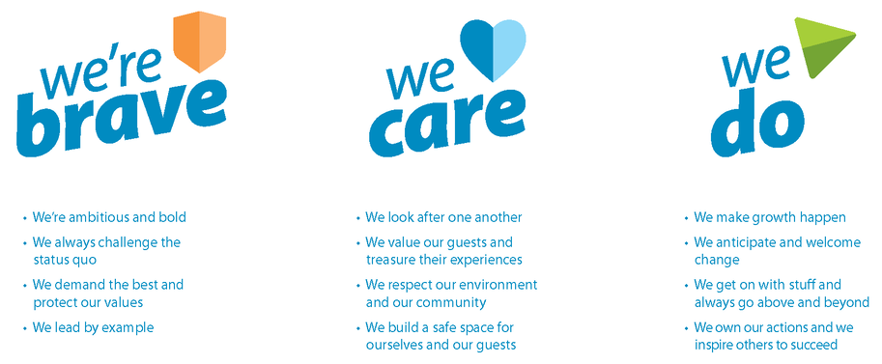

General:

Any other duties that are related to and consistent with the above Job Description as directed by the MTB/Zipline Manager.

Ensure full confidentiality is maintained at all times.

Attend staff training, induction and other professional development as directed.

Ensure all aspects of the Skyline Mission statement are upheld

Maintain a public image that is compatible with the highest possible standards whilst on the premises.

I accept the job description for the position of Bike Patrol / Zipline Guide.

Name: Date:

